**WATER LEVEL INDICATOR USING 555 TIMER**

**A MINI PROJECT REPORT**

*Submitted by:*

**C Bhavana Singh– 1NH18EE710**

**Shivangi Pandey– 1NH18EE749**

**R Supraja– 1NH18EE737**

***In partial fulfillment for the award of the degree of***

**Bachelors of Engineering (BE)**

**In**

Electrical & Electronics Engineering

**CHAPTER 1**

**INTRODUCTION**

Water Level Indicator might be characterized as a framework that shows the degree of water in any water supply. It is extremely easy to introduce and simple to utilize. The supplies required for structuring this circuit are promptly accessible in the market and of low worth. The circuit needn't bother with any AC assistant stock, it works on a Dc voltage source( 9v DC). Therefore, it is an exceptionally low utilization circuit. Additionally, the different the procedures occurring in the assembling of this framework doesn't have any impact on nature.

As we as a whole know, the savoring water India has arrived at its outrageous disturbing extents. It might before long lead to the idea of worldwide emergency. Hence, it is critical to protect the solution of life, water. The water tank flood at homes is one of the exceptionally basic issue to us that prompts the wastage of water which again prompts a ton of water misfortune. It is the obligation of each person to attempt to spare however much water as could reasonably be expected since it is valuable to us. The water tank floods as the degree of water in the tank can't be arbitrarily speculated. Likewise, once in a while people need to pause and quit doing different exercises until the tank is full which again is tedious. This issue can be constrained by planning a straightforward circuit, utilizing modest and promptly accessible electronic parts, called 'Water Level Indicator' which deals with the idea that water conducts power.

**BLOCK DIAGRAM**

Fig.1. Block Diagram

**CHAPTER 2**

**COMPONENTS REQUIRED**

* NE555 Timer
* Resistor,R1=1k
* Resistor,R2=100k
* Capacitor, C=2.2uf
* Buzzer
* 9v Battery
* Connecting wires

**DESCRIPTION OF COMPONENTS:**

**NE555 TIMER**:

It is an incorporated circuit utilized in a timer, pulse generation and oscillator applications.

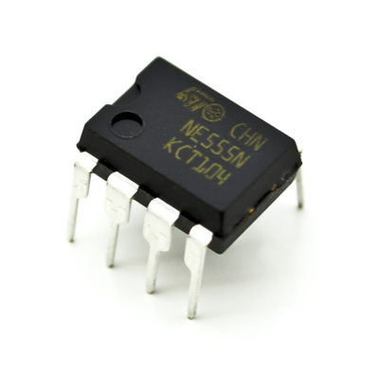

Fig.2. NE555 Timer

FEATURES:

* 555 clock can be worked at an enormous change of intensity supply from 5v to 18v.
* It is out there in three unique bundles eight stick metal will bundle, 8 stick DIP, 14 stick DIP
* Timing can be wherever from microseconds to hours.
* High yield current and may work in each astable and monostable modes.
* It fuses a temperature dependability of 0.005% per degree.

PIN DIAGRAM:

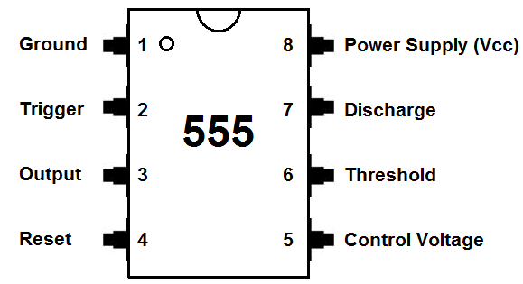

Fig.3. Pin Diagram

Pin 1 (Ground): Connects to the 0v power offer.

Pin 2 (Trigger): Detects 1/3 of rail voltage to make yield HIGH. Pin two has command over pin six. On the off chance that pin two is LOW, and pin six is LOW, yield proceeds to remain HIGH. In the event that pin six is HIGH, and pin two goes LOW, yield goes LOW though pin two LOW.

Pin 3 (Output): (Pins three and seven are in phase.) Goes HIGH and LOW and can deliver up to 200mA.

Pin 4 (Reset): Internally connected HIGH via 100k.

Pin 5 (Control): Open

Pin 6 (Threshold): Detects 2/3 of rail voltage to create output LOW provided that pin 2 is HIGH. This pin has a very high impedance (about 10M) and can trigger with about 0.2uA.

Pin 7 (Discharge):Goes LOW once 6 detects 2/3 rail voltage however pin 2 should be HIGH. If pin 2 is HIGH, pin 6 will be HIGH or LOW and pin 7 remains LOW. Goes OPEN (HIGH) and stays HIGH once pin 2 detects 1/3 rail voltage (even as an occasional pulse) once pin 6 is LOW. (Pins 7 and 3 are in phase) Pin 7 is equal to pin 3 however pin 7 doesn't go high - it goes OPEN. However it goes LOW and can sink about 200mA.

Pin 8 (Supply): Connects to the positive power supply (Vs). This may be any voltage between 4.5V and 15V DC.

**RESISTORS**:

A resistor is an aloof two terminal part which contradicts the progression of current and its restricting property is called resistance.

Resistors are utilized to lessen and control the progression of current in the circuit.

In the proposed framework, we utilize two resistors, 1Kohm resistor and a 100Kohm resistor.

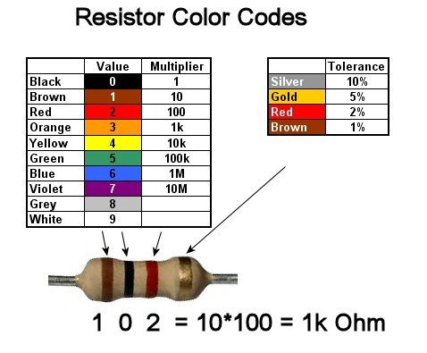

Fig.4. Color coding of 1k ohm resistor

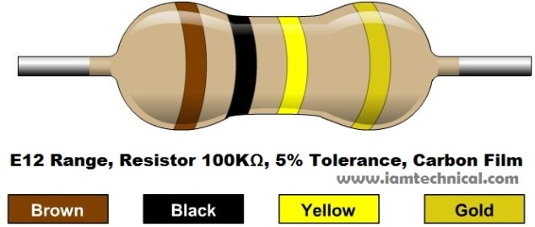

Fig.5. Color coding of 100k ohm resistor

**CAPACITORS:**

Capacitors are otherwise called condensers, they store energy. They are made of one or pair of conductors. The property controlled by it is known as capacitance and the unit seems to be 'Farad'.

Capacitor is a linear and a bilateral device. Capacitor keeps ohm's law, so it is a linear gadget. Current in a capacitor can move through both the sides or headings of a capacitor, henceforth it is likewise a bilateral gadget.

Capacitor has two terminals and current can move through any of these two terminals.

In the proposed system, we use a 2.2uF capacitor.

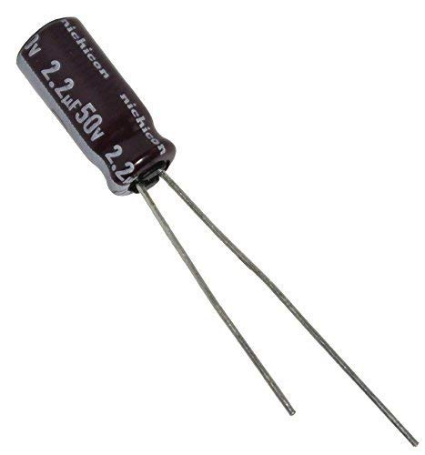

Fig.6. Capacitor

**BUZZERS:**

Buzzer is a mechanical gadget that is utilized to deliver a tone, alert or sound. It signals when the necessary water level is come to. A ringer or beeper is a sound hailing device, which may be mechanical, electromechanical, or piezoelectric (piezo for short). Average livelihoods of sign and beepers consolidate ready contraptions, tickers, and assertion of customer information.

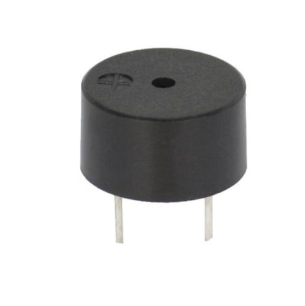

Fig.7. Buzzer

**BATTERY:**

Battery is a device which is having many electrochemical cells in it in series or in any fashion in order to store desired quantity of electrical energy.

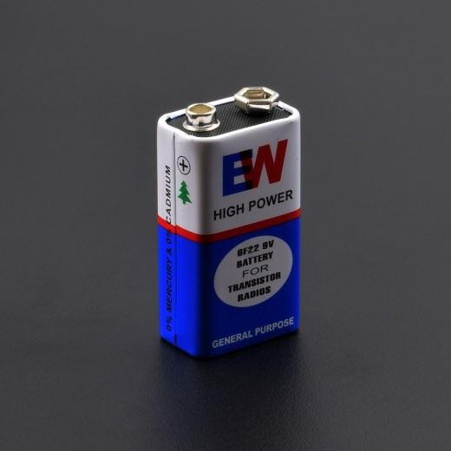

Fig.8. Battery

**CONNECTING WIRES**:

Connecting wires act as a medium for the progression of current starting with one point in the circuit then onto the next point.

They draw control from one point of the circuit and supply it to the necessary point.

Current can't go in air, and hence for the progression of current through the circuit we need a medium, which is given by the connecting wires with the goal that the circuit is shut.

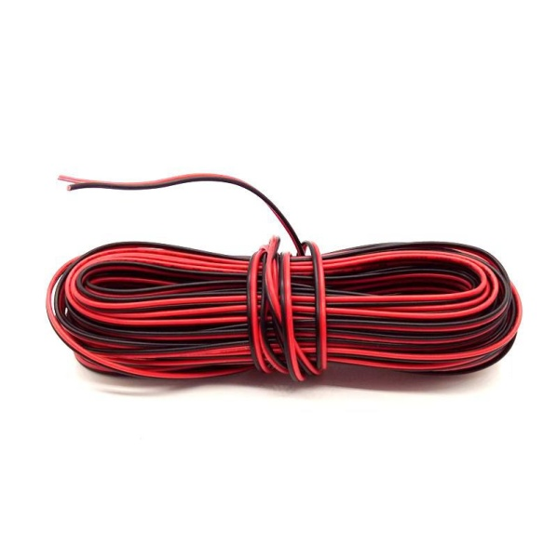

Fig.9. Connecting wires

**BREADBOARD**

A breadboard is a solderless device for brief model with equipment and test circuit structures. Most electronic parts in electronic circuits can be interconnected by embeddings their leads or terminals into the holes and a while later making associations through wires where proper.

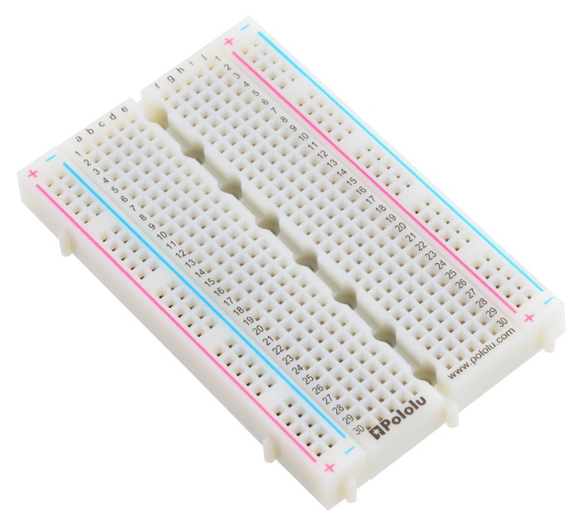

Fig.10 Breadboard

**CHAPTER 3**

**CIRCUIT DIAGRAM:**

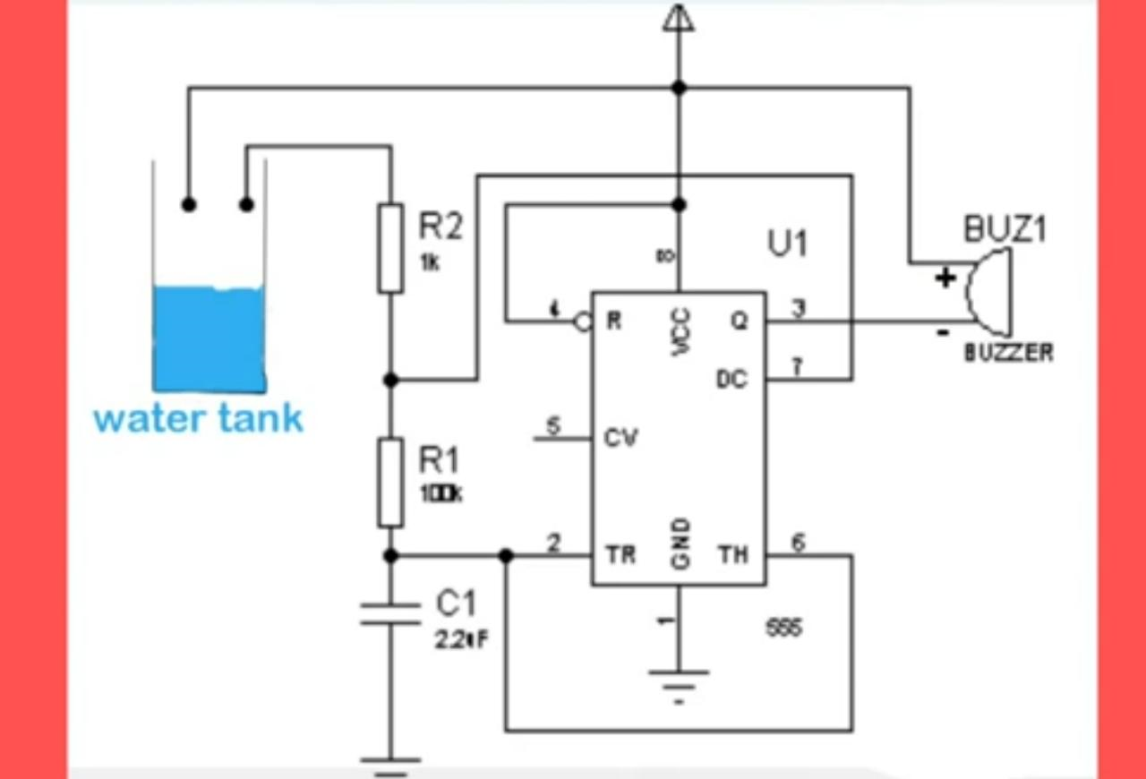

Fig.11. Circuit Diagram

**CONSTRUCTION:**

In the proposed system, the pins of the IC NE555 timer are connected accordingly,

* Pin 1 is connected to the ground
* Pin 2 and Pin 6 are shorted and connected to the terminals of the 2.2uF capacitor (which is grounded) and 100kohm resistor.
* Pin 3 is connected to the negative of the buzzer.
* Pin 4 is connected to the supply.
* Pin 7 is connected to the terminals of 1k and 100k resistors.
* Pin 8 is connected to the supply.

The positive terminal of the buzzer is given to one of the sensor probes and the 1k resistor is connected to the other sensor probe.

**WORKING:**

At the required level, the two probes that are shown in the circuit should be placed. Less than few centimeters should be the distance between the two probes to ensure that the conduction between the probes can take place when water is touched to these probes. When the 9v supply is given from the battery, the 555 circuit will get enabled and the output of the 555 timer produces a square wave output with a certain frequency when the water level rises to the height of the probes. This information is given back to the control panel to trigger the buzzer. Therefore the buzzer produces sound to give the output. Hence, it alerts us and we can switch off the motor.

The logic used in this circuit is, 555 timer is enabled when its reset pin is connected to logic high. As the water level is maximum the pin which is used is enabled and this helps to drive the 555 timer into a stable mode.

**CHAPTER 4**

**APPLICATIONS:**

Water level Indicator can be used in

* Hotels,
* Factories,
* Homes,
* Apartments,
* Commercial complexes,
* Drainage, etc.
* In underdeveloped rural areas.
* It can be fixed for single stage engine, three stage engines, fuel level pointer in vehicles, and fluid level marker in the colossal compartment organizations on the tank dividers.

**FUTURE WORK:**

We can improve the circuit by utilizing sensor in the circuit which will obstruct the power supply to the siphon or the engine. Accordingly the future venture won't be as less expensive as this one, yet we will attempt our best to keep it. At the point when the 9v supply is given from the battery, the 555 circuit will get empowered and the yield of the 555 clock creates a square wave yield with a specific recurrence when the water level ascents to the stature of the tests. This data is offered back to the control board to trigger the ringer. The bell produces sound to give the yield. Thus, it cautions us and we can turn off the engine. It tends to be fixed for single stage engine, three stage engines, fuel level marker in vehicles, and fluid level pointer in the enormous holder organizations on the tank dividers. We can improve the circuit by utilizing sensor in the circuit which will obstruct the power supply to the siphon or the engine. Accordingly the future task won't be as less expensive as this one, yet we will attempt our best to keep it. At the point when the 9v supply is given from the battery, the 555 circuit will get empowered and the yield of the 555 clock creates a square wave yield with a specific recurrence when the water level ascents to the tallness of the tests.

* Simple
* Affordable
* Easy to use
* Easy to install
* Available for all
* Smaller in size

**MODEL:**

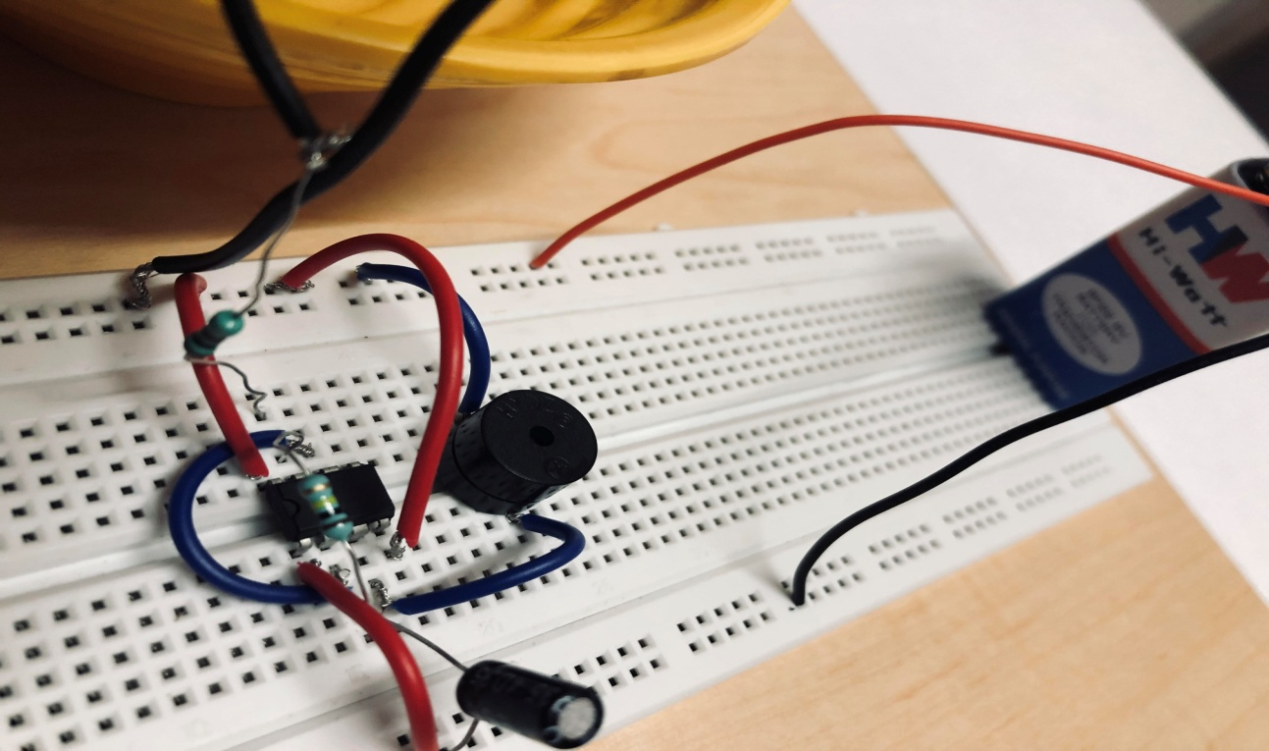

Fig.12a

This picture shows the components required for the construction of the water level indicator, that is

* NE555 Timer
* Capacitor
* Resistors
* Buzzer
* Battery
* Connecting wires

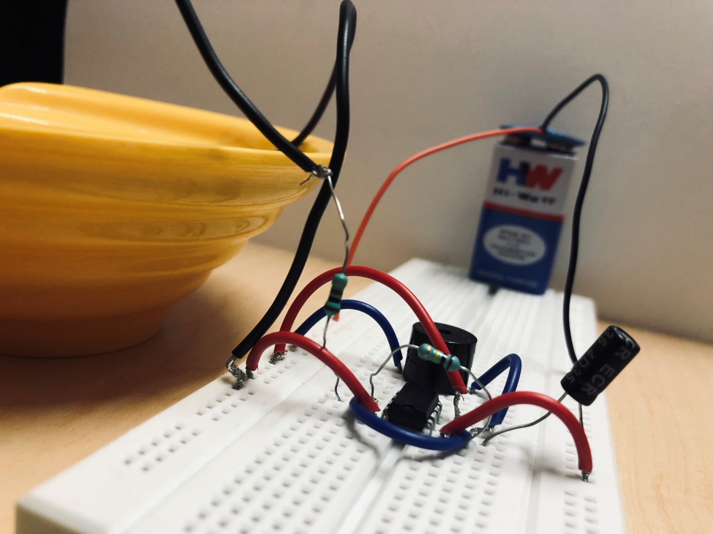 Fig. 12b

This picture shows the construction of the system.

As seen in the diagram,

* Pin1 is connected to the ground and Pin 8 is connected to the supply
* Pin 2 and Pin 6 are shorted
* Pin 3 is given to the output(buzzer)
* The resistors and capacitors are connected according to the circuit diagram

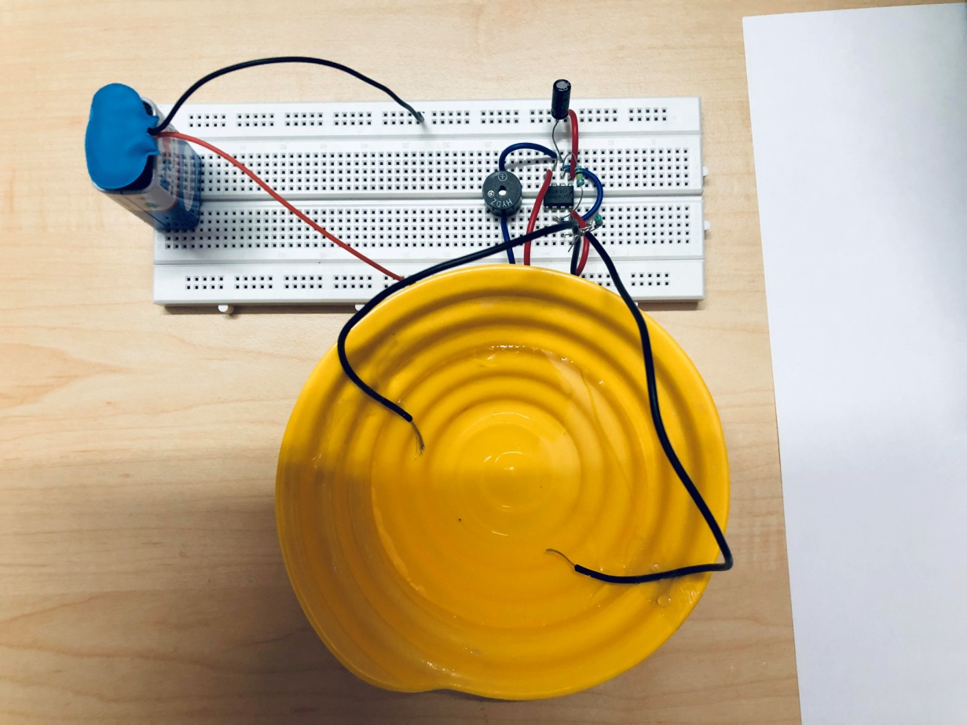

Fig.12.c

The picture shows the working of the water level indicator.

When the water reaches the required level, the two sensor probes which are placed at a minimal distance sense the water and conduct electricity hence completes the circuit and provides output to the buzzer which beeps to alert the person to switch off the motor

**CONCLUSION:**

The project has been effectively finished by having set up an easy to use and condition cordial framework which can be actualized utilizing basic, ease electronic parts.

Water level controller is a straightforward yet compelling approach to avoid wastage of water. Its effortlessness in plan and minimal effort parts make it a perfect bit of innovation for the normal man.

One of the essential necessities of every single living being, water, is being squandered because of the uncontrolled use and carelessness of individuals. In this way, it is significant that we attempt to control the wastage of water as much as we can.

Water level pointer is a basic electronic gadget that can assist us with sparing water by disturbing us when the water has arrived at the necessary level.

As the water arrives at the necessary level, the water level pointer utilizes the sensor tests to caution us that the water level has been come to and we can turn off the engine consequently avoiding the flood of water.

**REFERENCES:**

* [www.electronicshub.com](http://www.electronicshub.com)
* [www.slideshare.com](http://www.slideshare.com)
* [www.researchgate.net](http://www.researchgate.net)
* International Journal of Emerging Trends in Engineering and Development
* International Journal of scientific Research in Computer Science Engineering and Information Technology
* International Journal of Scientific & Engineering Research, Volume 7, Issue 4, April-2016